*Florida International University*

*School of Computing and Information Sciences*

Software Engineering Focus

Feature Document

User Story ID #149

**Name:** Remove Fellow

**Team Member(s):** Winicius Siqueira, Alfredo Morales

**Project:** Fellowship Management 1.0

**Product Owner(s)**: Robert Zurita

**Mentor(s)**: Mohsen Taheri

**Instructor**: Masoud Sadjadi

**User Story Name: Remove Fellow**

* As an Admin User I would like to remove a fellow that has been inactive for a few years so that active users are displayed.

Acceptance Criteria

* When an Admin User deletes a fellow from the Users List, then the fellow is removed from the User List.
* When an Admin User deletes a fellow from the Users List, then the fellow is removed from fellowships he/she applied to.

**Use Case**

* Name: Remove Fellow
* Actor: Admin User
* Preconditions: The Admin User is logged in and is viewing the Users List page.
* Description <Flow of events>: The Admin User clicks the “Delete” link on a row that is associated with a fellow. The Admin User is prompted “Are you sure?”. If the Admin User clicks Ok, then the fellow is removed from the list. If the Admin User clicks Cancel, then the fellow stays on the list.

**Use Case Diagram <**you can use draw.io**>**

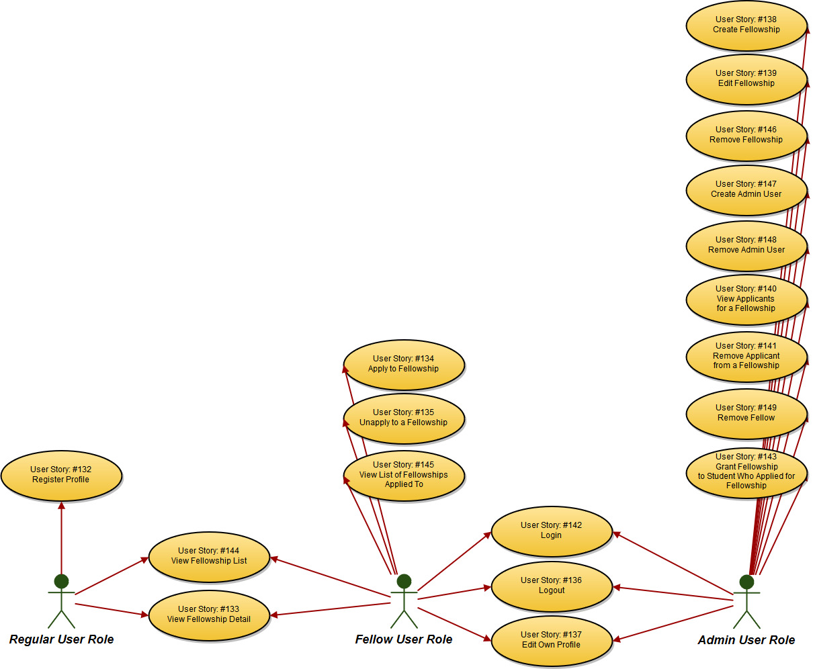

**Sequence Diagram**

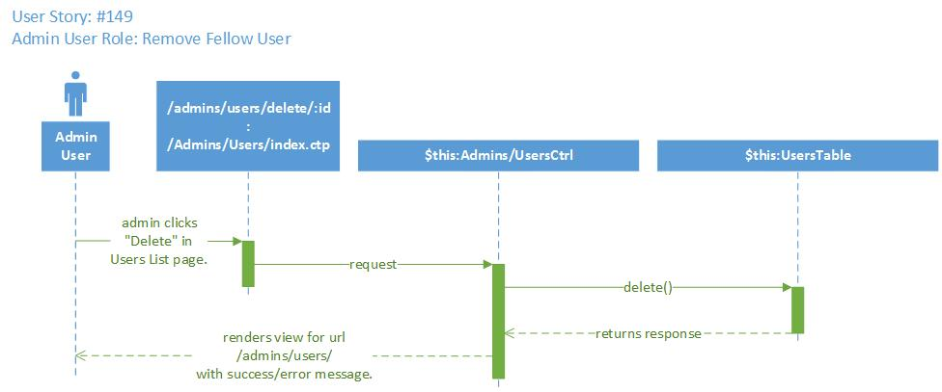

**Class Diagram**

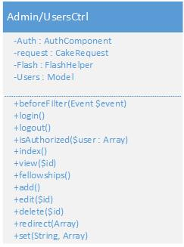

**Unit Test**

* Test case ID:
* Description/Summary of Test:
* Pre-condition:
* Expected Results:
* Actual Result:
* Status (Fail/Pass):

**Integration Test**

**Visual User Guide** <like one or two screenshots of the feature. For the hardware project, a photo of device is required>